**Cryptography and Network Security Lab**

**Name: Rushikesh R. Ware**

**PRN: 2020BTECS00012**

**Batch: B2**

**EUCLIDIAN ALGORITHM**

**Aim:**

To find GCD of two numbers using Euclidian algorithm.

**Theory:**

Examples:

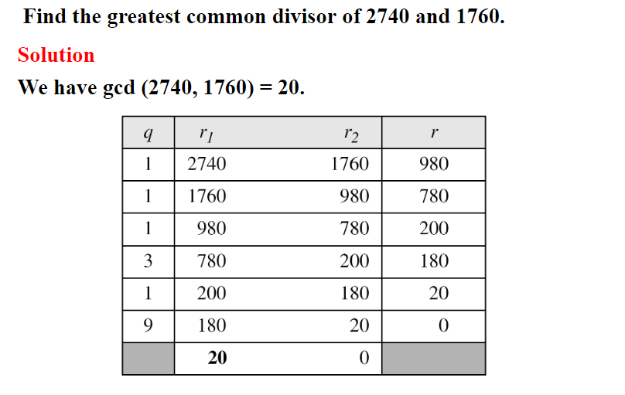

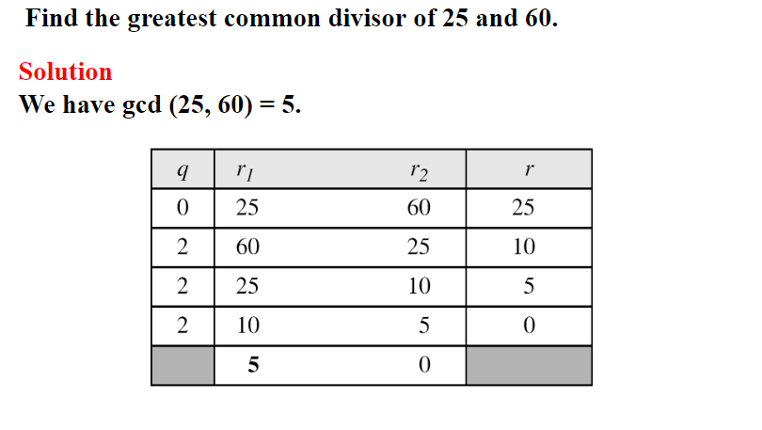

**Code:**

#include <bits/stdc++.h>

using namespace std;

int ansS, ansT;

int findGcdExtended(int r1, int r2){

    // Base Case

    if (r2 == 0){

        return r1;

    }

    int q = r1 / r2;

    int r = r1 % r2;

    cout << q << " " << r1 << " " << r2 << " " << r << endl;

    return findGcdExtended(r2, r);

}

int main()

{

    int num1, num2;

    cout << "\n Enter 1st number : ";

    cin >> num1;

    cout << "\n Enter 2nd number : ";

    cin >> num2;

    cout<<endl<< "q r1 r2 r" << endl;

    int gcd = findGcdExtended(num1, num2);

    cout <<endl<< "GCD is " << gcd << endl;

    return 0;

}

**Output:**

